Title

Author's Name & Surname1,*, Co-author's Name & Surname2

1 Author’s institution

2 Co-Author's institution

* Corresponding Author’s information (e-mail: myname@maildomain.com)

Abstract

The Abstract should not normally exceed 250 words and should be written as a single paragraph. It must clearly state the principal objectives and scope of the investigation, along with the methodology employed. The Abstract should summarize the key results, highlight the principal conclusions, and emphasize the novelty of the research. An effective abstract should stand on its own, making it understandable to a broad audience even when read independently of the full paper. To achieve this, avoid referencing figures, tables, equations, or the bibliography in the abstract. The use of acronyms should also be avoided where possible. If acronyms are necessary, they must be defined the first time they appear in the abstract and again in the main text of the paper. Finally, include 4 to 6 significant keywords following the abstract to enhance the discoverability of your paper.

**Keywords:** keyword, keyword, keyword, keyword, keyword

Highlights

* Highlights should be provided in the form of 3 or 4 bullet points.
* Highlights are a concise collection of core findings and originality of the research.
* Refer to the latest SV-JME paper for examples.
* Each highlight should be limited to 100 characters.

1. INTRODUCTION

The Introduction should provide a review of recent literature on the topic and sufficient background information to enable readers to understand and evaluate the results of the article, while bearing in mind the work’s relevance to this journal. It should clearly state the motivation for the work presented and prepare readers for the structure of the paper.

Start by offering context to orient readers who may be less familiar with the topic and establish the significance of your work. Then, articulate the need for your study by highlighting the gap between the current state of knowledge in the scientific community and the desired advancements. The final part of the Introduction should emphasize the key knowledge gaps identified in the literature review, particularly those directly addressed in this study. It should outline the paper's structure and summarize the methodological approaches employed. Conclude by explaining the relevance and potential impact of the study on the field, without discussing specific quantitative results. The Introduction should clearly demonstrate the significance of the study and highlight its originality or innovative aspects.

1. METHODS & MATERIALS

The Methods & Materials section provides a detailed account of the theoretical, computational, or experimental methods, as well as the materials used in your study. This section is crucial for ensuring that your work can be understood, replicated, and validated by other researchers. Clearly justify your choice of methods and describe the materials involved in sufficient detail.

This section can be separated into subsections, such as Experimental Setup, Data Reduction, Uncertainty Analysis, Materials, etc. This section should follow some general guidelines:

* Explain why the selected methods or approaches were chosen and how they align with the study’s objectives.
* Highlight any advantages or novelty of your methods compared to alternative approaches.
* List and describe all key materials, tools, or equipment used in your study (e.g., chemicals, reagents, software, hardware, or experimental apparatus).
* Specify the source or manufacturer of materials where appropriate.
* Include any special conditions (e.g., purity, preparation methods) that might influence the reproducibility of your work.
* If your work uses standard or commonly accepted procedures, clearly state this upfront.
* Reference established protocols, guidelines, or previous studies to support the reliability of your approach.
* Provide a clear and step-by-step explanation of your methodology (if applicable), including experimental setup data collection techniques, analytical or statistical tools, computational frameworks.
* Ensure that another researcher could replicate your study based on the provided details.
* If the methodological description is long, consider placing some of that information in a Supplementary Information file, while maintaining only the most critical information needed to understand the content of the work within the main manuscript.

1. Subtitle

You may organize the body of your paper into subsections, which should be numbered with a prefix indicating the corresponding section number.

Sub-subtitle

You may further divide the body of your paper into sub-subsections. Sub-subsection should not be numbered.

1. Article Types

*Original scientific paper* (1.01): Scientific papers should report significant and innovative results and exhibit a high level of originality. *Review scientific papers* (1.02): Review articles should be performed in the form of comprehensive, critical and systematic reviews. *Short scientific papers*(1.03): These generally have the same structure as longer scientific papers but are shorter (max 6 pages) and report on a significant, but limited, aspect of research work. Authors should use this template for all article types.

1. Symbols and Units

The SI system of units for nomenclature, symbols and abbreviations should be followed closely. Symbols for physical quantities within the text and equations should be written in italics (e.g., *v*, *T*, *n*), indices should be written in upright style (e.g., *v*ref, *T*o, *n*i), unless referring to the physical quantity, while vectors and matrices should be written in bold. See Eq. (2) for details. Symbols for units that consist of letters should be in plain text (e.g. m s-1, K, min, W m-2). For further details and guidelines, please follow the link: [*http://physics.nist.gov/cuu/pdf/sp811.pdf*](http://physics.nist.gov/cuu/pdf/sp811.pdf)*.*

1. Abbreviations

Abbreviations should be spelt out in full on first appearance followed by the abbreviation in parentheses, e.g., variable time geometry (VTG). The meaning of symbols and units belonging to symbols should be explained in each case or cited in a nomenclature section at the end of the manuscript before the References.

1. Figures

* Figures, including diagrams, technical drawings, illustrations, photographs, and other artwork, must be cited in the text in consecutive numerical order (e.g., Fig. 1, Fig. 2, etc.) and referred to in both the text and captions.
* Figures should be prepared without borders and placed on a white background.
* If a figure consists of multiple parts, each part should be labeled with a), b), c), etc., and an explanation for each part should be included in the caption.
* Captions must be self-explanatory, with no strict length limitation.

Ensure that all letters and numbers within figures are legible, using Arial or Times New Roman fonts with a recommended size of 6–10 pt. Consistent font types and sizes should be maintained across all manuscript figures.

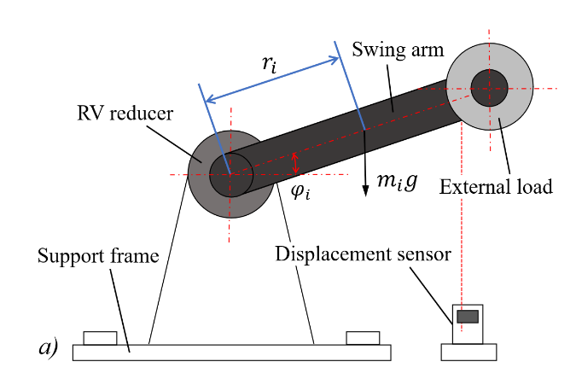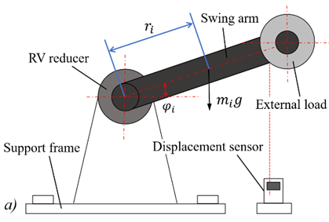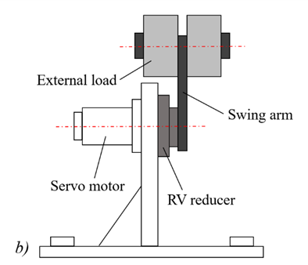

**Fig. 1.** A figure caption; a) explanation of part a; and b) explanation of part b

In addition to embedding figures at appropriate locations within the text, authors should also submit them separately in their original file formats (e.g., TIFF, BMP, GIF, JPG, or PDF) with a minimum resolution of 300 dpi. Graphs and line drawings should be prepared and uploaded as vector images (e.g., CDR, AI, or EMF). Avoid using print screens, and do not create multipart figures using MS Word canvas functionality.

1. Tables

Tables should carry separate titles and must be numbered in consecutive numerical order in the text and referred to in both the text and the captions as Table 1, Table 2, etc. Tables should not duplicate data found elsewhere in the manuscript. Tables should be prepared using a table editor as editable text and not inserted as a graphic. Units should be placed within square brackets, as shown in Table 1.

**Table 1.** Table title

|  |  |  |  |
| --- | --- | --- | --- |
| LDF | Line defects | Point defects | Precision [%] |
| Real quantity | 86 | 214 | 92.7 |
| Number of true positives | 65 | 213 |
| Number of false positives | 21 | 1 |

1. Equations

* Equations should be numbered in consecutive numerical order with the use of brackets in the text and referred to in the text as Eq. (1), Eq. (2), etc.
* The MS Word equation editor (LaTex editor) or MathType should be used for composing equations.
* Physical quantities and variables (such as *t*) should be in italics.
* Matrixes, vectors and tensors, such as one in Eq. (2), should be written in bold.
* Standard constants and indices should be written in an upright style, unless referring to the physical quantity (e.g., c1 and c*p*).

 (1)

 (2)

1. Decimal Notation

A period/full stop is used as the decimal point (3.14 instead of 3,14). The precision of numerical values should align with the level of uncertainty.

1. RESULTS and discussion

The Results and Discussion section may be presented as a single combined section or divided into two separate sections, depending on the nature of the study and the preference of the authors. This section is crucial for effectively communicating the outcomes of the research and their broader implications. Authors should ensure that the Results and Discussion section not only communicates their findings effectively but also underscores the relevance, innovation, and impact of their research within the broader context of mechanical engineering.

The Results should clearly and concisely present the data, supported by appropriate use of figures, tables, and graphs. The presentation must be objective, avoiding repetition of data already shown in visual elements. Highlight key findings that are central to the study while maintaining clarity and precision.

The Discussion should go beyond merely restating the results. It must provide an in-depth interpretation of the findings, exploring relationships, patterns, and generalizations that emerge. Discuss the significance of the results in the context of the study's objectives and relate them to previously published work. Where applicable, emphasize the novelty and originality of the findings and their contribution to advancing the field of mechanical engineering.

To maintain the scientific integrity of the work, both the Results and Discussion should reflect a high level of rigor and depth, appropriate for a scientific journal. Authors should aim to demonstrate how their research contributes to filling knowledge gaps, advancing existing theories, or proposing innovative applications. Papers published in this journal must align with the journal's broad scope, which encompasses all aspects of mechanical engineering. To meet these expectations, authors are encouraged to:

* Emphasize the novelty and originality of their work, demonstrating its contribution to the field.
* Address the practical applications of their findings, showing relevance to real-world engineering challenges or advancements.
* Tailor their discussion to a diverse readership, ensuring accessibility while maintaining scientific rigor.

1. CONCLUSIONS

The Conclusions section should succinctly summarize the key findings and highlight the most important outcomes of the study without repeating content from the abstract or discussion. It should focus on the significance and impact of the research while avoiding detailed results or explanations. Authors may also include a brief outlook on potential future research directions or applications related to the study's topic. A concise, well-crafted conclusion reinforces the value of the work and inspires further research.

Nomenclature

(Optional). A Nomenclature section may be omitted if all symbols are defined upon their first appearance in the manuscript. However, a Nomenclature section is strongly recommended for papers with numerous equations and symbols, even if these are defined within the text. Acronyms should be defined in the text and should not be included here. When providing a Nomenclature section, follow the example below:

*t*maxmaximal time limit, [min]

*T*0 initial temperature, [K]

REFERENCES

Citations within the manuscript and references in the reference section should be indicated using sequential numbers in square brackets (e.g., [1] or [2, 3] or [4-6]), assigned in the order they appear in the text. Every reference cited in the manuscript must be included in the reference list, and all entries in the reference section must be cited in the manuscript. Ensure that all references are complete and accurate. Whenever possible, include the DOI for each reference. Non-English references must be given in English translation with a concluding comment on the language of the reference, for example, “(in Polish)” after the reference.

A list of references must be included using the following examples as a guide. EndNote citation style is available on Guide for Authors web page: <https://www.sv-jme.eu/guide-for-authors-online/>

Journal Papers

Surname 1, Initials, Surname 2, Initials. Title. *Journal* **volume**, pages (year) **DOI: code**

Note that *Journal Title* is set in italics and abbreviated based on WoS@Caltech list of abbreviations: [https://library.caltech.edu](https://library.caltech.edu/c.php?g=512744&p=4327657).

[1] Hackenschmidt, R., Alber-Laukant, B., Rieg, F. Simulating nonlinear materials under centrifugal forces by using intelligent cross-linked simulations. *Stroj Vestn-J Mech E* **57**, 531-538 (2011) **DOI: 10.5545/sv-jme.2011.013**

Books

Surname 1, Initials, Surname 2, Initials. *Title*. Publisher (year) Place of publication

Note that the *Title of the Book* is italicized.

[2] Groover, M.P. *Fundamentals of modern manufacturing*. Wiley (2021) Hoboken

Book Chapters

Surname 1, Initials, Surname 2, Initials. Chapter title. EditorSurname 1, Initials, EditorSurname 2, Initials(ed(s).), *Book title*. Publisher (year) Place of publication, p. pages

Note that the *Book title* is italicized.

[3] Zupančič, M., Gregorčič, P. Laser surface engineering for boiling heat transfer applications. Hosseini, M., Karapanagiotis, I. (eds.), *Materials with extreme wetting properties: Methods and emerging industrial applications*. Springer (2021) Cham, p. 245-303

Proceedings Papers and Conference Papers

Surname 1, Initials, Surname 2, Initials. Paper title. *Proceedings title* or *Conference Name* (year) p. pages

Note that the *Proceedings Title* or *Conference Name* is italicized.

[4] Štefanić, N., Martinčević-Mikić, S., Tošanović, N. Applied lean system in process industry. *MOTSP Conference Proceedings* (2009) p. 422-427

Standards

Standard-Code (Rule Number). *Title*. Organisation (year) Place of publication

Note that the *Title of the* *Standard* is italicized.

[4] ISO 16573-2:2022. *Steel - measurement method for the evaluation of hydrogen embrittlement resistance of high-strength steels*. International Organization for Standardization (2022) Geneva

Web pages

Publisher or Company or Authors (Surname, Initials). Title. *URL*, accessed on: YYYY-MM-DD

Note that the *URL* is italicized.

[5] Strojniški vestnik-Journal of Mechanical Engineering. Guide for authors online. [*https://www.sv-jme.eu/guide-for-authors-online/*](https://www.sv-jme.eu/guide-for-authors-online/), accessed on 2024-12-04

Acknowledgements

(Optional). Authors should disclose the funding sources that supported the research conducted. Other acknowledgments, such as collaborations or assistance with the preparation of the manuscript, may also be included here.

Data Availability

(Obligatory). A data statement is required to enhance the reproducibility and transparency of published results. Authors must provide a data statement based on the following options:

* The data supporting the findings of this study are included in the article and/or its supplementary materials.
* The data supporting the findings of this study are openly available at [repository name] at [DOI or URL].
* The data that support the findings of this study are available from the corresponding author upon reasonable request.
* The data that support the findings of this study are not available due to [reason, e.g., lack of availability or destruction of data].

Author Contribution

(Obligatory). Author contributions and co-authorship should be acknowledged based on inclusivity and ethics following the Contributor Roles Taxonomy: <https://credit.niso.org/>. Please note that some authors may contribute through multiple roles while all the roles may not apply to every manuscript.

AI Assisted Writing

(Optional). If AI tools were used to assist in the writing, editing, or formatting of the manuscript, authors must disclose this information in a statement in this section. Authors should ensure that the final manuscript accurately represents their own ideas and contributions, as the use of AI does not diminish their accountability for the published work. The statement should specify the nature and extent of the assistance provided by the AI tool. Below is an example of how to structure this declaration:

"AI tools [name of tool(s)] were used in the preparation of this manuscript for [names specific tasks, e.g., grammar and language editing, formatting, etc.]. All content and conclusions remain the responsibility of the authors."

APPENDIX or SUPPLEMENTARY INFORMATION

(Optional). Appendices can be included at the very end of the manuscript. They are typically used for brief but essential descriptions, derivations, or figures that are critical to understanding the paper's content but are excluded from the main text to enhance readability and clarity. For lengthy definitions, extended explanations, or large figures, these should be included in a Supplementary Information file instead.

The Supplementary Information file should be submitted as a separate document during the submission process, while the formatting should be kept the same as defined within this template. The file should include:

* A title: "Supplementary Information"
* The manuscript title on the next line.
* A list of authors and their affiliations.
* The content of the Supplementary Information file, such as additional figures, tables, equations, or detailed explanations supporting the main text.

Content in the main manuscript may refer to figures, equations, or tables from the Supplementary Information file using appropriate references (e.g., Fig. S1, Eq. (S1), Table S1). This ensures a clear and consistent connection between the manuscript and the supplementary material.

The journal strongly encourages authors to provide a Supplementary Information file when applicable, as it enhances the clarity and comprehensiveness of the submission.